***PROJECT REPORT***

***COLLEGE NAME : GRT INSTITUTE OF ENGINEERING AND TECHNOLOGY.***

***COURSE NAME : ARTIFICILAL INTELLIGENCE.***

***PROJECT NAME : FAKE NEWS DETECTION USING NLP***

***Submitted By: SUJI.B***

***Mail Id: suji17062004@gmail.com***

***TABLE OF CONTENT***

|  |  |  |
| --- | --- | --- |
| *SI.NO* | *Title* | *Page no* |
| 01 | ***Aim and Abstract*** | ***2*** |
| 02 | ***Introduction*** | ***4*** |
| 03 | ***Problems in fake news detection*** | ***4*** |
| 04 | ***Ways to fix those problems*** | ***5*** |
| 05 | ***Design and innovation to solve the problem*** | ***7*** |
| 06 | ***Changes in design*** | ***9*** |
| 07 | ***Blocks to be added*** | ***11*** |
| *08* | ***Execution steps*** | ***14*** |
| *09* | ***Coding*** | ***15*** |
| *10* | ***Future scope*** | ***27*** |
| *11* | ***conclusion*** | ***29*** |
| *12* | ***Reference*** | ***30*** |

***AIM OF THE PROJECT:***

*The aim of fake news detection using NLP is to develop robust and accurate automated systems*

*that can:*

*1.* ***Identify Misleading Information*** *: Detect news articles or content that contains false or*

*misleading information.*

*2.* ***Prevent Dissemination****: Prevent the spread of fake news by identifying it at an early stage.*

*3.* ***Promote Trust****: Build trust among news consumers by providing reliable and accurate*

*information sources.*

*4.* ***Protect Democracy****: Safeguard democratic processes by reducing the impact of*

*misinformation on public opinion and elections.*

*5.* ***Provide Real-time Detection****: Offer real-time detection and alerts to help users make*

*informed decisions when consuming news.*

*6.* ***Trends Adapt to Emerging****: Stay up-to-date with evolving tactics used by fake news creators*

*and adapt detection methods accordingly.*

*7.* ***Balance Precision and Recall****: Achieve a balance between high precision (minimizing false*

*positives) and high recall (minimizing false negatives) to ensure effective detection without*

*overly censoring legitimate content.*

*8.* ***User Education****: Educate users about the risks of fake news and provide tools to verify*

*information.*

*9.* ***Ethical Considerations****: Address ethical concerns related to censorship and user privacy in*

*the context of fake news detection.*

*10.* ***Continuous Improvement****: Continuously refine and improve detection algorithms and*

*models based on user feedback and evolving techniques in NLP and machine learning.*

**Abstract**

The proliferation of fake news in the digital age has raised concerns about the veracity of information available online and its implications for society. Natural Language Processing (NLP), a subfield of artificial intelligence, has emerged as a potent tool for addressing this issue. This abstract provides a concise overview of the key themes and findings explored in the paper on fake news detection using NLP.In this paper, we delve into the application of NLP techniques and models to combat the spread of fake news. We examine the challenges posed by the generation and dissemination of deceptive information, explore the various methods used for fake news detection, and discuss the ethical considerations inherent in this endeavour. By analyzing the language, sources, and context of news content, NLP plays a pivotal role in identifying potentially misleading information. We highlight the strengths and limitations of NLP approaches, shedding light on the evolving landscape of fake news detection.

The findings in this paper underscore the importance of ongoing research and collaboration among researchers, technologists, and policymakers to refine NLP-based solutions for fake news detection. As society confronts the ramifications of fake news, NLP stands as a promising tool in the ongoing battle to preserve the integrity of information in the digital age.

**INTRODUCTION :** In an era where information flows freely and abundantly through digital channels, distinguishing between credible news and misleading informati5on has become increasingly challenging. Fake news, often defined as intentionally deceptive or false information presented as factual news, has the potential to influence public opinion, sway elections, and even incite social unrest. The proliferation of fake news poses a significant threat to the integrity of information dissemination and the very foundations of democracy.

To combat this issue, Natural Language Processing (NLP) has emerged as a powerful tool in the arsenal of fact-checkers, journalists, and technologists. NLP leverages the capabilities of artificial intelligence to analyze and understand the language used in news articles, social media posts, and other textual sources, enabling the identification of potential misinformation.

This paper delves into the realm of fake news detection using NLP, exploring the various techniques, models, and strategies employed in this crucial endeavor. It examines the challenges and complexities associated with distinguishing fake news from genuine reporting and discusses the ethical considerations involved in such detection efforts. By the end of this discussion, readers will have a comprehensive understanding of the role NLP plays in combating the spread of fake news and the implications for a more informed, reliable, and trustworthy information landscape.

***PROBLEMS IN FAKE NEWS DETECTION***

Detecting fake news using Natural Language Processing (NLP) is a complex task that comes with several challenges and potential problems:

*1.* ***Data quality and Quantity:*** Reliable labeled data for training NLP models is crucial. However, there may be limited labeled data available, and it can be biased or outdated, making it challenging to train accurate models.

2. ***Context Understanding:***  NLP models may struggle to grasp the context and subtleties of language, leading to misinterpretation of sarcasm, irony, or nuanced language in news articles.

3. ***Evolving Language:***  Language is constantly evolving, and NLP models can become outdated quickly, especially if they are not updated regularly to understand new phrases, slang, or cultural references.

4. ***Multilingual Challenges:***  Fake news is not limited to a single language. Multilingual models can face difficulties in accurately analyzing and classifying misinformation in various languages.

5. ***Source Verification:***  Determining the credibility of news sources can be challenging. NLP models may not have access to external databases or real-time information to verify the authenticity of a source.

6. ***Adversarial Attacks:*** Malicious actors may intentionally craft fake news to deceive NLP models. They can employ techniques like adversarial perturbations to bypass detection systems.

7. ***Confirmation Bias:***  NLP models can inadvertently reinforce users' existing beliefs by providing them with information that aligns with their biases, making it harder to change their perspectives.

8. ***Privacy Concerns:*** Analyzing the content of news articles can raise privacy concerns, especially if personal information is inadvertently extracted or if users' data is used without consent.

Addressing these challenges in fake news detection using NLP often requires a combination of advanced machine learning techniques, continuous model updates, human oversight, and collaboration with domain experts and fact-checking organizations. It's an ongoing effort to improve the reliability and effectiveness of these systems**.**

**WAYS TO FIX THESE PROBLEMS**

There are several ways to improve fake news detection using Natural Language Processing (NLP). Here are some strategies:

1. ***Better Data Collection :*** Collect a diverse and comprehensive dataset of both real and fake news articles. This data should cover various topics and writing styles to make the model more robust.

2. ***Feature Engineering :*** Develop better features to represent text. Consider using word embeddings to capture semantic meaning and TF-IDF for keyword-based features.

3. ***Advanced Models :*** Utilize more advanced NLP models, such as BERT, GPT, or their variants, which are pre-trained on large text corpora. Fine-tune these models on your fake news dataset for better performance.

4. ***Ensemble Learning :*** Combine predictions from multiple models or algorithms. Ensemble methods, like Random Forests or stacking, can often improve accuracy.

5. ***Linguistic Analysis :*** Analyze linguistic patterns in the text, such as sentence structure, grammar, and sentiment. Fake news articles may exhibit different linguistic characteristics compared to real news.

6. ***Fact-Checking Integration :*** Incorporate fact-checking databases or services into your pipeline to verify claims made in news articles. Cross-reference information with trusted sources.

7. ***User and Source Reputation :*** Consider the reputation of the source and the user sharing the news. If a source is known for spreading misinformation, it could be a red flag. Similarly, user history can be indicative of credibility.

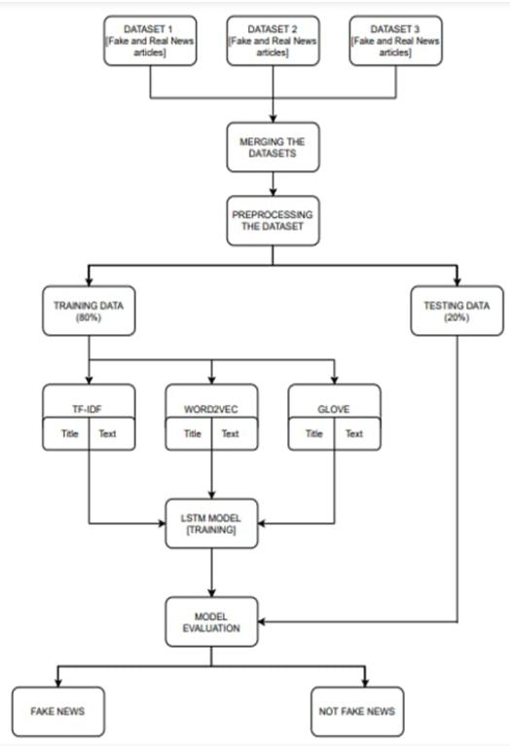**DESIGN**:

**INNOVATION TO SOLVE THE PROBLEMS IN THE DESIGN**

*Innovations in fake news detection using NLP continue to evolve as the battle against misinformation intensifies. Here are some new innovations and approaches in this field:*

1. **Multimodal Analysis**: *Integrating not only text but also images and videos for analysis. This approach considers the visual and auditory components of content, allowing for a more comprehensive evaluation of potential fake news.*
2. **Explainable AI (XAI):** *Developing NLP models that provide explanations for their decisions. This is crucial for transparency and understanding why a particular piece of content is classified as fake news, which can aid in building trust in the detection process.*
3. **Fine-tuning Pretrained Models:** *Leveraging pretrained language models like GPT-3 or BERT and fine-tuning them on domain-specific fake news datasets. This can improve the model's understanding of context and nuances.*
4. **Contextual Understanding:** *Going beyond keyword matching by focusing on the context in which words are used. This involves analyzing the entire article or conversation to detect inconsistencies or biased language.*
5. **Behavioral Analysis:** *Examining user behavior, such as posting patterns, frequency, and engagement with fake news content. Anomalies in user behavior can indicate the spread of misinformation.*
6. **Network Analysis:** *Studying the social network structure to identify suspicious sources and connections. Fake news often spreads through specific networks, and detecting these patterns can be valuable.*
7. **Real-time Detection:** *Developing systems that can detect and flag potential fake news in real-time as it emerges. This requires efficient processing and immediate response mechanisms.*
8. **Multilingual Support:** *Expanding fake news detection to multiple languages to address the global nature of the problem. Multilingual NLP models are being developed to support this.*
9. **Cross-platform Analysis**: *Considering the interconnected nature of the internet, analyzing fake news across various platforms and social media networks to detect coordinated misinformation campaigns.*
10. **Human-in-the-Loop AI:** *Combining the strengths of AI with human expertise to create hybrid systems that benefit from human judgment and domain knowledge.*

*These innovations collectively aim to make fake news detection using NLP more robust, accurate, and adaptable to the evolving strategies employed by purveyors of fake news. The field continues to advance, driven by interdisciplinary efforts involving linguistics, computer science, psychology, and data science.*

**CHANGES IN OUR DESIGN**

*The design of fake news detection systems using Natural Language Processing (NLP) has evolved and continues to change to improve their effectiveness and adaptability. Here are some key changes in the design of these systems:*

**1. Feature Engineering:** *Earlier designs relied heavily on traditional linguistic features such as TF-IDF and Bag of Words. Now, the focus has shifted to more advanced word embeddings like Word2Vec, Glove, and BERT-based embeddings, capturing semantic relationships and context better.*

**2. Deep Learning Architectures:** *There has been a shift towards deep learning architectures like Convolutional Neural Networks (CNNs), Recurrent Neural Networks (RNNs), and Transformers (e.g., BERT, GPT) to model complex linguistic patterns and dependencies effectively.*

**3. Transfer Learning:** *Pre-trained language models, such as BERT and GPT, are fine-tuned for fake news detection tasks, allowing models to leverage large-scale pre-training on massive text corpora, which improves their generalization.*

**4. Multi-Modal Analysis:** *To combat fake news with manipulated media, systems now integrate computer vision and audio analysis alongside NLP to detect inconsistencies between text and accompanying visuals or audio.*

*5.* **Explainability:**  *There is a growing emphasis on making fake news detection models more interpretable and explainable to build trust. Techniques like attention mechanisms and gradient-based saliency maps are used to visualize model decision-making.*

**6. Real-time Processing:** *The design now often includes real-time processing to quickly identify and flag potentially fake news as it spreads on social media or news platforms.*

**7. Continuous Learning:** *Fake news is constantly evolving, so models are designed to continuously learn and adapt to new tactics used by misinformation creators.*

**8. Cross-Lingual Support:** *Many systems are now designed to detect fake news in multiple languages to address the global nature of the problem.*

**9. User Behavior Analysis:** *Incorporating user interactions, such as sharing, commenting, and engagement patterns, to identify potential sources of misinformation or flag suspicious content.*

**10. Ensemble Methods:** *Combining the outputs of multiple models or algorithms to improve detection accuracy and reduce false positives/negatives.*

**11. Bias Mitigation:** *Efforts are made to reduce biases in fake news detection models to ensure fairness and prevent the amplification of certain perspectives.*

**12. Privacy-Preserving Techniques:** *Designing systems that respect user privacy, such as federated learning or on-device processing, to avoid the need for centralized data collection.*

**13. Human-in-the-Loop Systems:** *Some designs incorporate human reviewers or moderators to work alongside automated systems, enhancing accuracy and addressing complex cases.*

**14. Fact-Checking Integration:** *Integrating external fact-checking organizations and databases to verify the factual accuracy of claims made in news articles.*

**16. Collaborative Filtering:** *Implementing collaborative filtering techniques to recommend trustworthy sources and articles based on user preferences and trust networks.*

*These changes in design reflect the growing complexity of the fake news problem and the need for more advanced and adaptable solutions. Continuous research and development in the field of NLP are essential to stay ahead of evolving misinformation tactics.*

**BLOCKS TO BE ADDED**

*Creating a complete block diagram for a fake news detection system using NLP is a complex task, but I can provide a simplified representation of the key components and their connections. Please note that this is a high-level overview, and actual system architecture may vary based on specific requirements and technologies used.*

***Here's a simplified block diagram:***

*Data Collection Block*

*DATA COLLECTION BLOCK*

*|*

*v*

*PREPROCESSING BLOCK*

*FEATURE EXTRACTION BLOCK*

*DEEP LEARNING MODELS BLOCK*

*EXPLAINABILITY BLOCK*

*USER BEHAVIOR ANALYSIS BLOCK*

*PRIVACY PRESERVING BLOCK*

*HUMAN IN THE LOOP BLOCK*

*COLLABORATIVE FILTERING BLOCK*

*FINAL DECISION*

* *The "Data Collection Block" collects news articles, social media posts, or other textual data from various sources.*
* *The "Preprocessing Block" cleans and standardizes the text data, performs language identification, and handles multimedia content if necessary.*
* *The "Feature Extraction Block" extracts relevant features from the preprocessed data, such as word embeddings, sentiment scores, and named entities.*
* *-The "Deep Learning Models Block" includes deep learning models for fake news detection, which take the extracted features as input.*
* *The "Explainability Block" provides explanations for the model's decisions, enhancing transparency.*
* *The "Real-Time Processing Block" handles incoming data streams and makes real-time predictions.*
* *The "Continuous Learning Block" updates and retrains the models to adapt to evolving misinformation tactics.*
* *The "Cross-Lingual Support Block" ensures the system can handle multiple languages.*
* *The "User Behavior Analysis Block" monitors user interactions and patterns.*
* *The "Ensemble Block" combines the outputs of multiple models for improved accuracy.*
* *The "Privacy-Preserving Block" protects user privacy.*
* *The "Human-in-the-Loop Block" involves human reviewers in the decision-making process.*
* *The "Fact-Checking Integration Block" integrates with external fact-checking resources.*
* *The "Blockchain Verification Block" verifies source authenticity using blockchain.*
* *The "Collaborative Filtering Block" recommends trustworthy sources based on user preferences and trust networks.*
* *Finally, the "Final Decision" is made based on the outputs of the various blocks, determining whether a piece of content is fake or not.*

*Please note that the actual implementation and connections between these blocks may vary depending on the system's complexity and specific goals. This diagram provides a high-level overview of the components involved in a fake news detection system using NLP.*

**DATA PREPROCESSING:**

After gathering the data, you must preprocess it to make sure it is clean and suitable for analysis. This entails:

Handling missing data: If any of the fields have missing values, you may need to fill them up or delete the entries that correspond to them.

Data encoding: Genre and language categories have to be encoded into a category-specific format. This is achievable. utilizing methods like label encoding or one-hot encoding

Feature scaling: if you intend to employ algorithms that are sensitive to feature scales, such as gradient descent- based approaches, you might need to scale numerical features like runtime to have similar ranges.

Outlier detection: Find any unusual trends in the IMDb ratings or runtime that might skew the forecasts and deal with them.

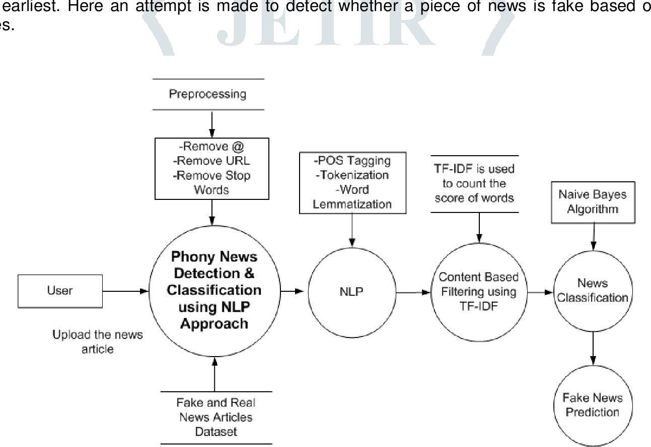

**EXECUTION STEPS:**

Step 1: Importing Libraries.

Step 2: Importing the Dataset.

Step 3: Assigning Classes to the Dataset.

Step 4: Checking Number of Rows and Columns in the Dataset. Step 5: Manual Testing for Both the Dataset.

Step 6: Assigning Classes to the Dataset.

Step 7: Merging Both the Dataset

**IMPORTING DATASET:**

import pandas as pd

import numpy as np

import seaborn as sns

import matplotlib.pyplot as plt

from sklearn.model_selection import train_test_split

from sklearn.metrics import accuracy_score

from sklearn.metrics import classification_report

import re

import string

df_fake = pd.read_csv(“/content/Fake.csv.zip”)

df_true = pd.read_csv(“/content/True.csv.zip”)

df_fake.head()

OUT:

|  |  |  |  |  |
| --- | --- | --- | --- | --- |
|  | Title | text | subject | date |
| 0 | Donald Trump Sends Out Embarrassing New Year’... | Donald Trump just couldn t wish all Americans ... | News | December 31, 2017 |
| 1 | Drunk Bragging Trump Staffer Started Russian ... | House Intelligence Committee Chairman Devin Nu... | News | December 31, 2017 |
| 2 | Sheriff David Clarke Becomes An Internet Joke... | On Friday, it was revealed that former Milwauk... | News | December 30, 2017 |
| 3 | Trump Is So Obsessed He Even Has Obama’s Name... | On Christmas day, Donald Trump announced that ... | News | December 29, 2017 |
| 4 | Pope Francis Just Called Out Donald Trump Dur... | Pope Francis used his annual Christmas Day mes... | News | December 25, 2017 |

df_true.head(5)

OUT:

|  |  |  |  |  |
| --- | --- | --- | --- | --- |
|  | Title | Text | subject | date |
| 0 | As U.S. budget fight looms, Republicans flip t... | WASHINGTON (Reuters) - The head of a conserve... | politicsNews | December 31, 2017 |
| 1 | U.S. military to accept transgender recruits o... | WASHINGTON (Reuters) - Transgender people will... | politicsNews | December 29, 2017 |
| 2 | Senior U.S. Republican senator: 'Let Mr. Muell... | WASHINGTON (Reuters) - The special counsel inv... | politicsNews | December 31, 2017 |
| 3 | FBI Russia probe helped by Australian diplomat... | WASHINGTON (Reuters) - Trump campaign adviser ... | politicsNews | December 30, 2017 |
| 4 | Trump wants Postal Service to charge 'much mor... | SEATTLE/WASHINGTON (Reuters) - President Donal... | politiesNews | December 29,2017 |

Inserting a column “class”as target feature

df_fake[“class”] = 0

df_true[“class”] = 1

df_fake.shape, df_true.shape

((23481, 5), (21417, 5))

# Removing last 10 rows for manual testing:

df_fake_manual_testing = df_fake.tail(10)

for i in range(23480,23470,-1):

df_fake.drop([i], axis = 0, inplace = True)

df_true_manual_testing = df_true.tail(10)

for i in range(21416,21406,-1):

df_true.drop([i], axis = 0, inplace = True)

df_fake.shape, df_true.shape

((23471, 5), (21407, 5))

df_fake_manual_testing[“class”] = 0

df_true_manual_testing[“class”] = 1

<ipython-input-10-3aaf8ec2aad1>:1: SettingWithCopyWarning:

A value is trying to be set on a copy of a slice from a DataFrame.

Try using .loc[row_indexer,col_indexer] = value instead

df_fake_manual_testing[“class”] = 0

<ipython-input-10-3aaf8ec2aad1>:2: SettingWithCopyWarning:

A value is trying to be set on a copy of a slice from a DataFrame.

Try using .loc[row_indexer,col_indexer] = value instead

df_true_manual_testing[“class”] = 1

df_fake_manual_testing.head(10)

|  |  |  |  |  |  |
| --- | --- | --- | --- | --- | --- |
|  | **title** | **text** | **subject** | **date** | **class** |
| **23471** | Seven Iranians freed in the prisoner swap have... | 21st Century Wire says This week, the historic... | Middle-east | January 20, 2016 | 0 |
| **23472** | #Hashtag Hell & The Fake Left | By Dady Chery and Gilbert MercierAll writers ... | Middle-east | January 19, 2016 | 0 |
| **23473** | Astroturfing: Journalist Reveals Brainwashing ... | Vic Bishop Waking TimesOur reality is carefull... | Middle-east | January 19, 2016 | 0 |
| **23474** | The New American Century: An Era of Fraud | Paul Craig RobertsIn the last years of the 20t... | Middle-east | January 19, 2016 | 0 |
| **23475** | Hillary Clinton: ‘Israel First’ (and no peace ... | Robert Fantina CounterpunchAlthough the United... | Middle-east | January 18, 2016 | 0 |
| **23476** | McPain: John McCain Furious That Iran Treated ... | 21st Century Wire says As 21WIRE reported earl... | Middle-east | January 16, 2016 | 0 |
| **23477** | JUSTICE? Yahoo Settles E-mail Privacy Class-ac... | 21st Century Wire says It s a familiar theme. ... | Middle-east | January 16, 2016 | 0 |
| **23478** | Sunnistan: US and Allied ‘Safe Zone’ Plan to T... | Patrick Henningsen 21st Century WireRemember ... | Middle-east | January 15, 2016 | 0 |
| **23479** | How to Blow $700 Million: Al Jazeera America F... | 21st Century Wire says Al Jazeera America will... | Middle-east | January 14, 2016 | 0 |
|  |  |  |  |  |  |
|  |  |  |  |  |  |

df_true_manual_testing.head(10)

df_manual_testing = pd.concat([df_fake_manual_testing,df_true_manual_testing], axis = 0)

df_manual_testing.to_csv(“manual_testing.csv”)

Merging True and Fake Dataframes:

df_merge = pd.concat([df_fake, df_true], axis =0 )

df_merge.head(10)

|  |  |  |  |  |
| --- | --- | --- | --- | --- |
| **title** | **text** | **subject** | **date** | **class** |
| **0** Donald Trump Sends Out Embarrassing New Year’... | Donald Trump just couldn t wish all Americans ... | News | December 31, 2017 | 0 |
| **1** Drunk Bragging Trump Staffer Started Russian ... | House Intelligence Committee Chairman Devin Nu... | News | December 31, 2017 | 0 |
| **2** Sheriff David Clarke Becomes An Internet Joke... | On Friday, it was revealed that former Milwauk... | News | December 30, 2017 | 0 |
| **3** Trump Is So Obsessed He Even Has Obama’s Name... | On Christmas day, Donald Trump announced that ... | News | December 29, 2017 | 0 |
| **4** Pope Francis Just Called Out Donald Trump Dur... | Pope Francis used his annual Christmas Day mes... | News | December 25, 2017 | 0 |
| **5** Racist Alabama Cops Brutalize Black Boy While... | The number of cases of cops brutalizing and ki... | News | December 25, 2017 | 0 |
| **6** Fresh Off The Golf Course, Trump Lashes Out A... | Donald Trump spent a good portion of his day a... | News | December 23, 2017 | 0 |
| **7** Trump Said Some INSANELY Racist Stuff Inside ... | In the wake of yet another court decision that... | News | December 23, 2017 | 0 |
| **8** Former CIA Director Slams Trump Over UN Bully... | Many people have raised the alarm regarding th... | News | December 22, 2017 | 0 |
| **9** WATCH: Brand-New Pro-Trump Ad Features So Muc... | Just when you might have thought we d get a br... | News | December 21, 2017 | 0 |

df_merge.columns

index([‘title’,’text’,’subject’,’data’,’class’],dtype=’object’)

Removing columns which are not required

df = df_merge.drop([“title”,” subject”,”date”], axis = 1)

df.isnull().sum()

text 0

class 0

dtype: int64

Random Shuffling the dataframe

df = df.sample(frac = 1)

df.head()

|  |  |  |
| --- | --- | --- |
|  | **text** | **class** |
| **7701** | Bobby Jindal abandoned his home state of Louis... | 0 |
| **16528** | Newsflash Hillary WAR is not aesthetically ple... | 0 |
| **9527** | WASHINGTON (Reuters) - The White House confirm... | 1 |
| **18516** | Texas Democrat Rep. Al Green announced on Wedn... | 0 |
| **993** | WASHINGTON (Reuters) - The U.S. State Departme... | 1 |

df.reset_index(inplace = True)

df.drop([“index”], axis = 1, inplace = True)

df.columns

Index([‘text’, ‘class’], ‘object’)

df.head()

1. Bobby Jindal abandoned his home state of Louis... 0
2. Newsflash Hillary WAR is not aesthetically ple... 0
3. WASHINGTON (Reuters) - The White House confirm... 1
4. Texas Democrat Rep. Al Green announced on Wedn... 0
5. WASHINGTON (Reuters) - The U.S. State Departme... 1

def wordopt(text):

text = text.lower()

text = re.sub(‘\[.*?\]’, &#39;&#39;, text)

text = re.sub(“\\; &quot;,text)

text = re.sub(&#39;https?://\S+|www\.\S+&#39;, &#39;&#39;, text)

text = re.sub(&#39;&lt;.*?&gt;+&#39;, &#39;&#39;, text)

text = re.sub(&#39;[%s]&#39; % re.escape(string.punctuation), &#39;&#39;, text)

text = re.sub(&#39;\n&#39;, &#39;&#39;, text)

text = re.sub(&#39;\w*\d\w*&#39;, &#39;&#39;, text)

return text

df[“text”] = df[“text”].apply(wordopt)

Defining dependent and independent variables

x = df[“text”]

y = df[“class”]

Splitting Training and Testing:

x_train, x_test, y_train, y_test = train_test_split(x, y, test_size=0.25)

Convert text to vectors from

sklearn.feature_extraction.text import TfidfVectorizer

vectorization = TfidfVectorizer()

xv_train = vectorization.fit_transform(x_train)

xv_test = vectorization.transform(x_test)

Logistic Regression:

from sklearn.linear_model import LogisticRegression

LR = LogisticRegression()

LR.fit(xv_train,y_train)

▾ LogisticRegression LogisticRegression()

pred_lr=LR.predict(xv_test)

LR.score(xv_test, y_test)

0.9868983957219252

print(classification_report(y_test, pred_lr))

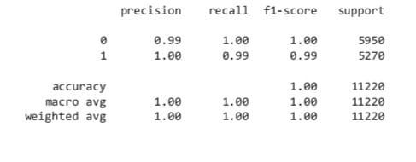

Decision Tree Classification :

from sklearn.tree import DecisionTreeClassifier

DT = DecisionTreeClassifier()

DT.fit(xv_train, y_train)

pred_dt = DT.predict(xv_test)

DT.score(xv_test, y_test)

0.9952762923351158

print(classification_report(y_test, pred_dt))



GradientBoostingClassifier:

from sklearn.ensemble import GradientBoostingClassifier

GBC = GradientBoostingClassifier(random_state=0)

GBC.fit(xv_train, y_train)

pred_gbc = GBC.predict(xv_test)

GBC.score(xv_test, y_test)

0.9955436720142602

print(classification_report(y_test, pred_gbc))



Random Forest Classifier:

from sklearn.ensemble import RandomForestClassifier

RFC = RandomForestClassifier(random_state=0)

RFC.fit(xv_train, y_train)

pred_rfc = RFC.predict(xv_test)

RFC.score(xv_test, y_test)

0.9881461675579323

print(classification_report(y_test, pred_rfc))



Model Testing :

def output_lable(n):

if n == 0:

return "Fake News"

elif n == 1:

return "Not A Fake News"

def manual_testing(news):

testing_news = {"text":[news]}

new_def_test = pd.DataFrame(testing_news)

new_def_test["text"] = new_def_test["text"].apply(wordopt)

new_x_test = new_def_test["text"]

new_xv_test = vectorization.transform(new_x_test)

pred_LR = LR.predict(new_xv_test)

pred_DT = DT.predict(new_xv_test)

pred_GBC = GBC.predict(new_xv_test)

pred_RFC = RFC.predict(new_xv_test)

return print("\n\nLR Prediction: {} \nDT Prediction: {} \nGBC Prediction: {} \nRFC Prediction: {}".format(output_lable(pred_LR[0]), output_lable(pred_GBC[0]), output_lable(pred_RFC[0])))

news = str(input())

manual_testing(news)  
 news = str(input())

manual_testing(news)

}news = str(input())

manual_testing(news)

**FUTURE SCOPE:**

1. **Linguistic Analysis:**

- Text structure and grammar analysis.

- Sentiment analysis to assess emotional tone.

- Analysis of writing style and patterns.

2. **Source Evaluation:**

- Analyzing the credibility and history of news sources.

- Detecting clickbait headlines or sensationalism.

3. **Fact-Checking:**

- Comparing claims in news articles to known facts.

- Identifying inconsistencies and contradictions.

4. **Contextual Analysis**:

- Understanding the context and background of news stories.

- Analyzing social media comments and discussions for context.

5. **Named Entity Recognition**:

- Identifying people, organizations, and locations mentioned in news articles.

- Cross-referencing entities with credible sources.

6. **Metadata Examination**:

- Investigating timestamps and publication history.

- Analyzing image and video metadata for authenticity.

7. **Multimedia Analysis:**

- Detecting manipulated images, audio, and video content.

- Assessing deepfake technology in multimedia.

8. **User-Generated Content**:

- Analyzing social media posts and comments for potential misinformation.

- Identifying bots and fake accounts.

9. **Machine Learning Models**:

- Leveraging NLP models, such as BERT or GPT, for automated analysis.

- Training classifiers on labeled datasets for fake news detection.

10**. Ethical Considerations**:

- Addressing issues related to privacy, censorship, and bias in fake news detection.

- Ensuring responsible use of NLP technology in this domain.

The scope of features for fake news detection using NLP encompasses a wide range of linguistic, contextual, and technological elements, highlighting the multidimensional approach required to combat misinformation effectively.

**CONCLUSION:**

The battle against fake news is an ongoing and complex one, and Natural Language Processing (NLP) has proven to be an invaluable ally in this fight. As this paper has highlighted, NLP techniques and models have enabled us to make significant strides in identifying and mitigating the impact of misinformation.

In conclusion, it is evident that fake news detection using NLP is not a panacea but a promising avenue for addressing the challenges posed by the spread of misleading information. NLP models have evolved to detect linguistic cues, fact-check claims, and analyze sources, offering a multi-faceted approach to assessing the credibility of news content.

Nonetheless, it is crucial to recognize that fake news detection is an evolving field, and challenges persist. NLP models must continually adapt to evolving disinformation tactics and the nuances of language. Furthermore, ethical considerations surrounding privacy, bias, and censorship must be carefully navigated to avoid unintended consequences.

As society grapples with the consequences of fake news, the efforts of researchers, engineers, and policymakers are crucial. By harnessing the capabilities of NLP and fostering interdisciplinary collaborations, we can continue to improve our ability to identify and combat fake news, promoting a more reliable and trustworthy information ecosystem for all. Fake news may persist, but through the power of NLP, we can work toward a future where the truth prevails, ensuring that information remains a force for good in society.

##### References

[1] S. M. Metev and V. P. Veiko, Laser Assisted Microtechnology, 2nd ed., R. M. Osgood, Jr., Ed. Berlin, Germany: Springer-Verlag, 1998. [2] J. Breckling, Ed., The Analysis of Directional Time Series: Applications to Wind Speed and Direction, ser. Lecture Notes in Statistics. Berlin, Germany: Springer, 1989, vol. 61. [3] S. Zhang, C. Zhu, J. K. O. Sin, and P. K. T. Mok, “A novel ultrathin elevated channel low-temperature poly-Si TFT,” IEEE Electron Device Lett., vol. 20, pp. 569–571, Nov. 1999. [4].